**[10 Heuristic Principles – Jakob Nielsen’s (Usability Heuristics)](http://www.uxness.in/2015/02/10-heuristic-principles-jakob-nielsens.html)**

A [heuristic evaluation](https://www.interaction-design.org/literature/topics/heuristic-evaluation?ep=uxness) is a usability inspection method for computer software that helps to identify usability problems in the user interface (UI) design. It specifically involves evaluators examining the interface and judging its compliance with recognized [usability principles](https://www.interaction-design.org/literature/topics/design-principles?ep=uxness) (the "heuristics").   
Jakob Nielsen's [heuristics](https://www.interaction-design.org/literature/topics/heuristics?ep=uxness) are probably the most-used usability heuristics for user interface design. Nielsen developed the heuristics based on work together with Rolf Molich in 1990.The final set of heuristics that are still used today were released by Nielsen in 1994. Also known as ''Usability Heuristics', 'Nielsen heuristics'.

**1. Visibility of system status**

The system should always keep users informed about current state and actions through appropriate visual cues and feedback within reasonable time.

[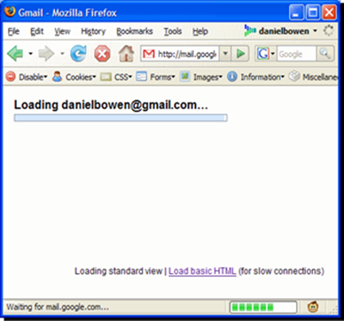](http://lh4.ggpht.com/-_lTJS1XKwyk/VOmZ5adB0VI/AAAAAAAAAT4/8YGnhdUNARU/s1600-h/image%25255B9%25255D.png)

Gmail loading a user’s mailbox. Tells the user to wait & Indicates the status of what’s going on.

[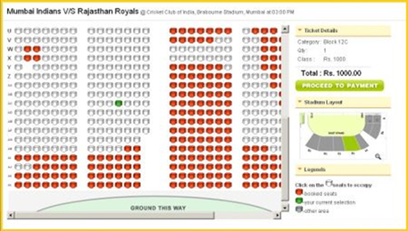](http://lh5.ggpht.com/-mt0uq3nmgtQ/VOmZ8DbDkeI/AAAAAAAAAUI/qloYi-qiXng/s1600-h/image%25255B7%25255D.png)

Proper presentation of available seats and booked seats with price and other details.

**2. Match between system and the real world**

The system should speak the users' language, with words, phrases and concepts familiar to the user, rather than system-oriented terms. Follow real-world conventions, making information appear in a natural and logical order.

[](http://lh4.ggpht.com/-kQtCya1cJeU/VOmZ_ZKVeEI/AAAAAAAAAUY/LEPAlZJkFco/s1600-h/image%25255B84%25255D.png)

iBooks iPad application using the metaphor of wooden book shelf.

[](http://lh4.ggpht.com/-k-6P9OhRciQ/VOmaBekFk3I/AAAAAAAAAUo/DziB47fu70k/s1600-h/image%25255B82%25255D.png)

Using real life metaphor in computer application.

**3. User control and freedom**

Users often choose system functions by mistake and will need a clearly marked "emergency exit" to leave the unwanted state without having to go through an extended dialogue. Support undo and redo.   
  
[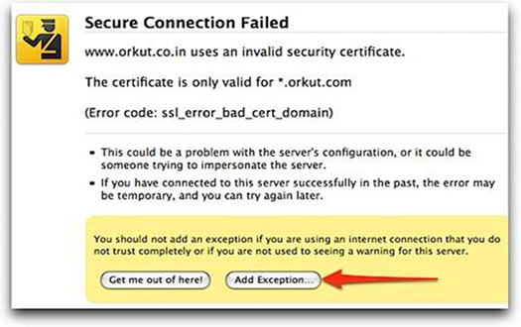](http://lh3.ggpht.com/-cY-9IzrN2u0/VOmaDCKRClI/AAAAAAAAAU4/kTen6UasaEQ/s1600-h/image%25255B80%25255D.png)  
  
Mozilla suggesting some security tips and handling exception.

[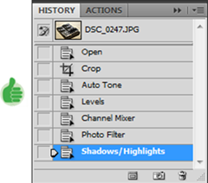](http://lh6.ggpht.com/-A3G1M2hIeLY/VOmaEmCioCI/AAAAAAAAAVI/JsUiLUcitO4/s1600-h/image%25255B74%25255D.png)

History in Photoshop helps user in recovering previous steps.

**4. Error prevention**

Even better than good error messages is a careful design which prevents a problem from occurring in the first place. Either eliminate error-prone conditions or check for them and present users with a confirmation option before they commit to the action.

[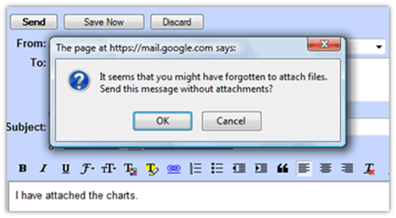](http://lh3.ggpht.com/-uLdzxqTebYw/VOmaF6GWmBI/AAAAAAAAAVY/4TBTxPLCdQY/s1600-h/image%25255B73%25255D.png)

**5. Help users recognize, diagnose, and recover from errors**

Error messages should be expressed in plain language (no codes), precisely indicate the problem, and constructively suggest a solution.

[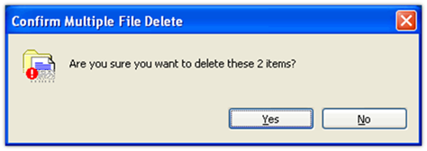](http://lh3.ggpht.com/-QT_9U4x9o_8/VOmaHEqdzlI/AAAAAAAAAVo/sc9hdTDHOtQ/s1600-h/image%25255B71%25255D.png)

**6. Consistency and standards**

Users should not have to wonder whether different words, situations, or actions mean the same thing. Follow platform conventions.

[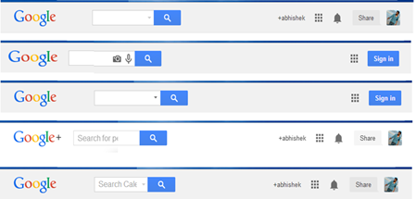](http://lh3.ggpht.com/-efQ47rLzXT0/VOmaJG9FQdI/AAAAAAAAAV4/QkahQ2OSPZ8/s1600-h/image%25255B69%25255D.png)

[](http://lh4.ggpht.com/-7Cr2O9r3JTk/VOmaKZ01ihI/AAAAAAAAAWI/vlPpEfhHrZw/s1600-h/image%25255B67%25255D.png)

Inconsistent Icons.

**7. Recognition rather than recall**

Minimize the user's memory load by making objects, actions, and options visible. The user should not have to remember information from one part of the dialogue to another. Instructions for use of the system should be visible or easily retrievable whenever appropriate.

[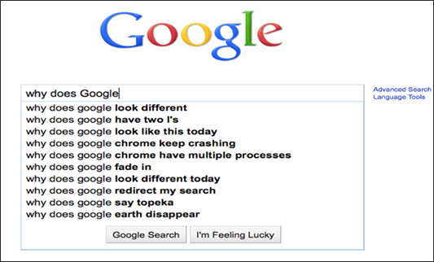](http://lh6.ggpht.com/-FEam4xJyJzg/VOmaL2gdVpI/AAAAAAAAAWY/rMtpcN2sw8k/s1600-h/image%25255B63%25255D.png)

**8. Flexibility and efficiency of use**

Accelerators --unseen by the novice user --may often speed up the interaction for the expert user such that the system can cater to both inexperienced and experienced users. Allow users to tailor frequent actions.

[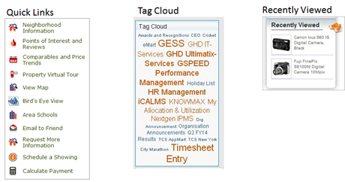](http://lh5.ggpht.com/-0TBcRRqAevA/VOmaNQhmztI/AAAAAAAAAWo/RQyaHfz7b8A/s1600-h/image%25255B65%25255D.png)

Auto-fills

[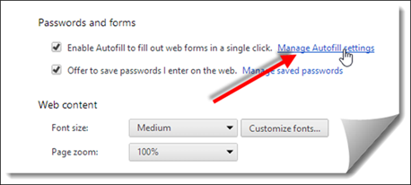](http://lh5.ggpht.com/-6INYb6S8hQw/VOmaO_QYNfI/AAAAAAAAAW4/T35kfrB-xpE/s1600-h/image%25255B64%25255D.png)

**9. Aesthetic and minimalist design**

Dialogues should not contain information which is irrelevant or rarely needed. Every extra unit of information in a dialogue competes with the relevant units of information and diminishes their relative visibility.

[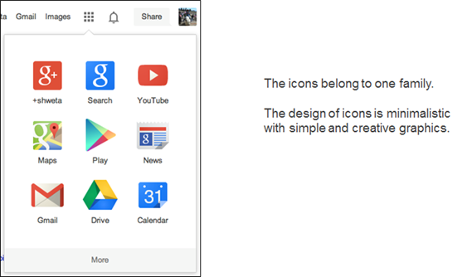](http://lh4.ggpht.com/-74cwwxwkM4w/VOmaQWSlyLI/AAAAAAAAAXI/05U2xVzG5p4/s1600-h/image%25255B59%25255D.png)

**10. Help and Documentation**

Even though it is better if the system can be used without documentation, it may be necessary to provide help and documentation. Any such information should be easy to search, focused on the user's task, list concrete steps to be carried out, and not be too large.

[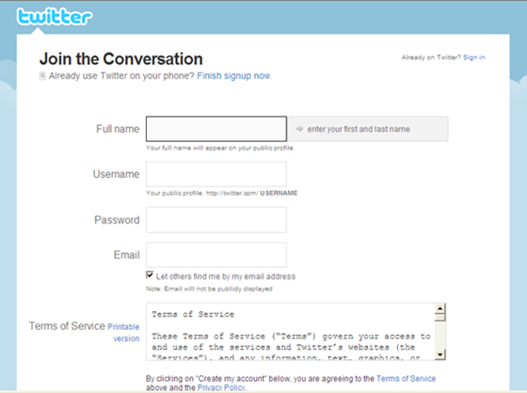](http://lh6.ggpht.com/-q83vRYwKjwY/VOmaUyl5tvI/AAAAAAAAAXo/QshZTvYGnX8/s1600-h/image%25255B57%25255D.png)

Contextual help is the best way to help !   
Also, telling users about the consequences of their actions is also very helpful.